**National University of Computer & Emerging Sciences (NUCES) Islamabad,**

Department of Computer Science

**Programming Fundamentals – Fall 2022**

**LAB 06**



**Learning Outcomes**

In this lab you are expected to learn the following:

* Selection Controls

**Syntax of If:**

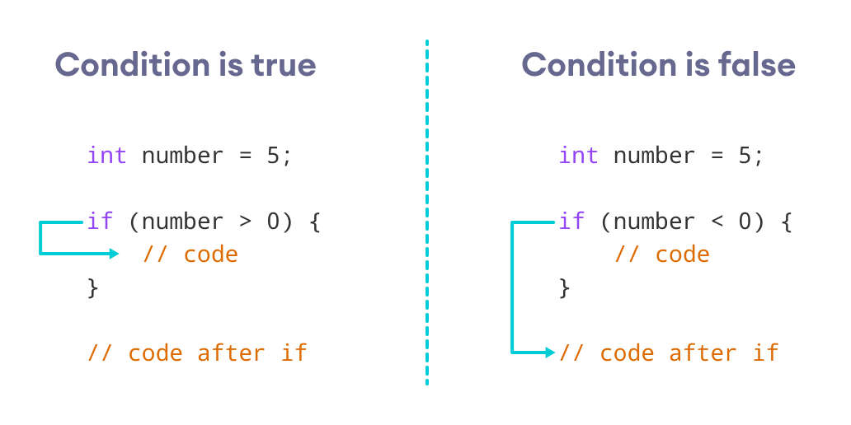

**Example of If:**

**Syntax of If-Else:**

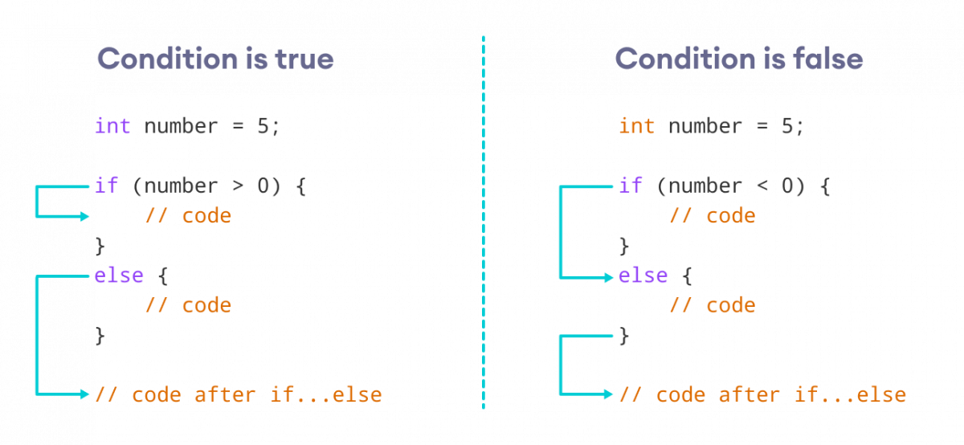

**Example of If-Else:**

**Syntax of Nested If-Else:**

**Notes:**

* We can add else and else if statements to the inner if statement as required.
* The inner if statement can also be inserted inside the outer else or else if statements (if they exist).
* We can nest multiple layers of if statements.

**Example of Nested If-Else:**

**Task 01:**

Write a program that determines whether character entered by user is Vowel or Consonant.

**Output 1:**

**Input: ‘A’**

**Output: Vowel**

**Output 2:**

**Input: ‘C’**

**Output: Consonant**

**Task 02:**

*Note: [Use IF-ELSE]*

Write a Program which takes Grade of a student as input, and shows earned GPA against this entered grade. Grades varies from A+ to D and F.

Your program must be able to handle invalid input e.g. shows a message if input is invalid.

**Task 03:**

Write a program that takes a number as input and checks if the number is positive. If it’s positive, the program should check whether the number is a multiple of 5 or not. If it is, then it should print True otherwise false. **Use nested ifs/else.**

**Task 04:**

Write down a program which takes three numbers as input from user and shows number having intermediate value (between large and small value).

**Input: 21 33 45**

**Output:33**

**Task 05:**

Write a program that calculates the bill of electricity with following considerations:

Take no. of units as user input.

**1)Prices per unit**

i)Rate of unit price is 9 if no of units is less than 100.

ii)Rate of unit price is 11 if no of units is less than 200 and greater than 100.

iii)Rate of unit price is 9 if no of units is less than 300 and greater than 200.

**2)Tax addition**

i)Tax is 5% if total bill is less than 750.

ii) Tax is 7% if total bill is greater than 750.

**Task 6:**

***Note: You are only allowed to use nested if-else statements for this program***

Write a program to print the largest number among the three numbers (input by user).

**Task 7:**

***Note: You are only allowed to use nested if-else statements for this program***

Write a program to check if all three numbers (input by user) are equal.

|  |
| --- |
| **Submission Instructions:**  1.Save all **.cpp** files with your roll no and task number  **e.g. i22XXXX_Task06.cpp**   1. Now create a new folder/directory with name *ROLLNO_LAB06* **e.g. i22XXXX_LAB06** 2. Move all of your .cpp files to this newly created directory and compress it into **.zip file**. 3. Now you have to submit this zipped file on Google Classroom. |

**THE END**